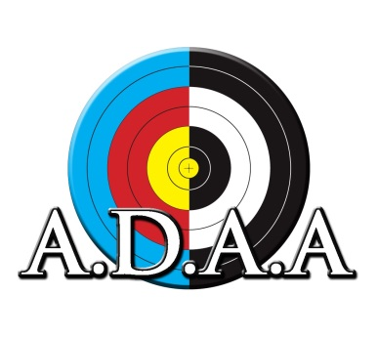

**ADAA Field Championships**

**Saturday and Sunday 28 and 29 September**

**Franklin County Archers  
22 Stone Rd, Bombay**

Registration Form:

Name:

Email:

Phone:

Bow Type:

IFAA Division:

Club:

Please circle which day you intend to shoot (for ADAA you must shoot both days):

SATURDAY 3D SUNDAY IFAA FIELD

Both Days:

Adult - $40, Junior and Cubs – $30, Family (2 adults 2 kids) $100

ADAA fees Saturday:  
Adult - $25.00  
Junior - $20.00  
Family - $100

IFAA & ADAA Sunday:  
Adult - $15.00  
Junior - $10.00

*Entries to Franklin County Archers (franklincountyarchersnz@gmail.com)*

*Bank account: 12 3028 0529 313 00 (include reference surname and ADAA Field)*