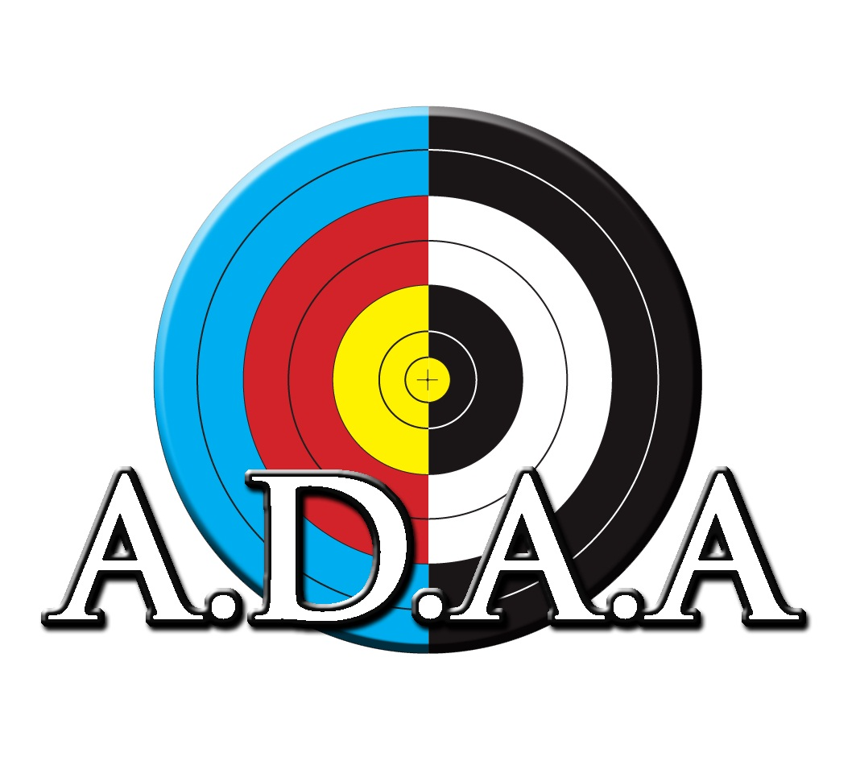
Entry Form
Youth Fun Xmas BBQ and Fun Shoot 2022

Get together a team of 3 archers (any youth age, we recommend a mix of bow-types) and come enjoy a morning and lunch of fun and festivities.

Name of Team: …………………………………………………………………….....………………………………

Contact details for Team: ……………………………………………………….…………………………………
Please put down your cellphone number in case the event is postponed. We do not cancel for rain unless there is chance of thunder.

Team Members: Age group Bow type
1
2
3

The Auckland District Archery Association account number for payment is:
12-3629-0108565-00
Team or surname and YTT in reference fields please. You can pay on the day.

Venue: Mountain Green Archery Club

Entry Fees: $30 per team

Entries to: Caro Geelen adaa.secretary@gmail.com

Any questions please email or call Caro on 021 183 1233

